A PROJECT REPORT
Submitted for
IOT BASED SYSTEMS (UEC640)

Project Title: IoT-Enabled Smart Soil Health Monitoring System with Laser-Based Data Transmission

BE Third Year Submitted By
Rubalpreet Kaur (102306155)
Sheryl Varshney (102306156)
Yashita Gupta (102306158)
Aditya Tayal (102306233)
Suyash Shah (102486237)

Group No: 4 Subgroup: 3F23
Lab Faculty: Dr. Amanpreet Kaur


DEPARTMENT OF ELECTRONICS AND COMMUNICATION ENGINEERING THAPAR INSTITUTE OF ENGINEERING AND TECHNOLOGY, PATIALA, PUNJAB, INDIA
(Jan-May, 2026)

Abstract
In modern agriculture, efficient soil monitoring plays a crucial role in improving crop productivity and optimizing resource utilization. This project presents the design and implementation of a soil monitoring system that measures essential soil parameters such as moisture content and nutrient composition (Nitrogen, Phosphorus, and Potassium – NPK) using embedded sensor technology. The system integrates a capacitive soil moisture sensor and an RS485-based NPK sensor with a dual Arduino Uno setup to ensure reliable data acquisition and transmission.
A unique aspect of this project is the implementation of a laser-based optical communication system for data transmission between two nodes—transmitter and receiver—eliminating the need for conventional radio frequency (RF) communication. The transmitter unit collects real-time data from the sensors, processes it using an Arduino Uno, and encodes it into digital signals. These signals are then transmitted via a 650 nm laser diode in the form of light pulses. On the receiver side, a photosensitive LDR module (LM393) detects variations in light intensity and converts them back into electrical signals. The receiving Arduino decodes this information to reconstruct the original sensor data.
The developed solution demonstrates a low-cost, interference-free approach for precision agriculture monitoring that is particularly suited for environments where radio-frequency communication is restricted or unreliable.
Experimental results indicate successful data transmission at baud rates up to 9600 baud over short-range line-off sight distances, with soil moisture readings accurate to within ±2% of calibrated reference values, temperature measurements within ±0.5°C, and pH estimation within ±0.2 pH units. This system is suitable for greenhouse automation, smart irrigation control, and research-grade soil analysis platforms.

Keywords
IoT, Soil Health Monitoring, Laser Communication, Free Space Optical (FSO) Transmission, Soil Moisture Sensor, pH Sensing, Arduino, On-Off Keying, LDR, Precision Agriculture, Smart Irrigation, Sensor Fusion, NPN Transistor Driver

Introduction

General Background
The agricultural sector is undergoing a fundamental transformation driven by the convergence of the Internet of Things (IoT), embedded sensing, and wireless communication technologies. Precision agriculture, which aims to optimize resource usage and maximize crop yield through data-driven decision-making, relies critically on the continuous, accurate, and timely acquisition of soil health parameters. Soil moisture, temperature, and pH are three of the most influential variables governing plant growth, nutrient availability, and irrigation scheduling. Traditional soil monitoring approaches involve manual sampling, laboratory analysis, and periodic field visits, which are time consuming, expensive, and incapable of capturing the dynamic temporal variation of soil conditions across agricultural fields.
The integration of IoT with soil sensing enables autonomous, real-time monitoring without human intervention. However, most existing IoT-based soil monitoring systems rely on conventional radio-frequency wireless communication protocols such as Wi-Fi, Zigbee, LoRa, or Bluetooth for data transmission. While effective in many deployments, these RF-based systems are susceptible to electromagnetic interference, frequency congestion in

industrial agricultural environments, regulatory restrictions on RF transmission in certain regions, and multipath fading in dense vegetation environments. The exploration of alternative communication media for agricultural IoT systems represents an important and underexplored research direction.
Laser-based free-space optical (FSO) communication offers a compelling alternative, leveraging the directional, high-bandwidth, and interference-free nature of coherent light for data transmission. While FSO systems have been extensively studied for long-range metropolitan and satellite communication links, their application at short-range, low-power, embedded system scales for agricultural IoT remains largely unexplored. This project investigates the feasibility and performance of integrating laser-based optical data transmission with a multi-parameter soil health monitoring platform, contributing to the emerging field of optical IoT for precision agriculture.

Specific Problem
Current soil health monitoring systems face several interrelated technical limitations that restrict their effectiveness in real-world agricultural deployments. Conventional RF-based IoT sensor nodes are susceptible to electromagnetic interference generated by agricultural machinery, electric fencing systems, and high-voltage irrigation pumps that are ubiquitous on modern farms. The crowded 2.4 GHz and 915 MHz ISM bands used by Wi-Fi, Zigbee, and LoRa experience increasing congestion as the density of IoT devices in agricultural environments grows, degrading transmission reliability. Additionally, battery-powered wireless sensor nodes require periodic maintenance and replacement, and their RF transmitters consume significant power during continuous operation.
From the soil sensing perspective, existing platforms typically monitor only one or two soil parameters, failing to provide a holistic view of soil health. The simultaneous monitoring of moisture, temperature, and pH in a single integrated system with real-time wireless transmission to a cloud dashboard has not been adequately addressed in the literature at the low-cost, embedded system scale targeted by this project. Furthermore, the absence of a validated, low-cost optical data transmission mechanism for agricultural IoT applications represents a clear technical and research gap that this project directly addresses.

Proposed Solution
This project proposes an integrated smart soil health monitoring platform that combines multi-parameter soil sensing with laser-based free-space optical data transmission and IoT cloud connectivity. The transmitter module employs a soil moisture sensor, LM35 temperature sensor, and analog pH sensor module connected to an Arduino Uno microcontroller, which encodes the collected data into a structured ASCII packet of the format and transmits it via a 5V laser module driven by an NPN transistor switching circuit at a controlled baud rate. The receiver module employs a second Arduino Uno connected to a light-dependent resistor (LDR) in a voltage divider configuration to detect and decode the laser-modulated serial signal. Decoded data is displayed locally on an serial monitor.
The target outcome is a functional prototype that demonstrates reliable soil health data acquisition and optical wireless transmission, with a measured localization accuracy sufficient for single-plot agricultural monitoring, a battery life compatible with solar-powered deployment, and a cloud dashboard providing real-time telemetry and automated irrigation alerts. It is important to note that this project is a research-grade proof of concept demonstrating the feasibility of laser-based optical communication for agricultural IoT, rather than a fully productized commercial system.

Key Contributions
This work presents a soil monitoring system that integrates both soil moisture and NPK sensing to provide a comprehensive assessment of soil conditions, addressing limitations of existing systems that primarily focus on a single parameter [1][3]. A key contribution of the proposed system is the use of laser-based optical communication for data transmission, offering an interference-free and secure alternative to conventional RF-based methods widely used in agricultural monitoring [3][5]. The implementation follows fundamental principles of optical communication, extending their application to embedded agricultural systems [6][7].
In addition, the system is designed to be low-cost and easy to implement using readily available components, making it suitable for deployment in resource-constrained environments where IoT-based solutions may not be practical [1][5]. The prototype demonstrates real-time sensing and transmission, highlighting the feasibility of combining embedded sensing with optical communication and providing a foundation for future enhancements in smart agriculture systems.

Literature Review

Overview of Existing Research
Recent advancements in agriculture have led to the development of smart monitoring systems that utilize sensors and embedded technologies to improve crop productivity and resource efficiency. Several researchers have explored the use of Internet of Things (IoT) and wireless sensor networks (WSNs) for real-time monitoring of soil parameters such as moisture, temperature, and nutrient content.
Balaji and Kumar [1] proposed an IoT-based smart farming system where environmental parameters are monitored using sensors and transmitted to a cloud platform for analysis. Their system enables remote monitoring but relies heavily on internet connectivity and cloud infrastructure.
Similarly, Agrawal and Singhal [2] developed a smart irrigation system using Arduino and Raspberry Pi, which automates irrigation based on soil moisture levels. While the system reduces water wastage, it focuses only on moisture sensing and does not consider soil nutrient content.
Nandurkar et al. [3] introduced a precision agriculture system using wireless sensor networks, where multiple sensor nodes collect data and transmit it via RF communication. Although effective, RF-based systems are prone to interference and may require higher power consumption.

Methods Used in Previous Work
Most existing agricultural monitoring systems employ RF-based communication methods such as Wi-Fi, Zigbee, GSM, or LoRa for data transmission. These technologies enable long-range communication and integration with IoT platforms, as demonstrated in various embedded and automation systems [5]. However, RF communication is susceptible to electromagnetic interference, signal congestion, and security vulnerabilities, particularly in environments with multiple electronic devices.
In contrast, optical communication has been widely studied as an alternative communication technique due to its inherent advantages such as high bandwidth, immunity to electromagnetic interference, and enhanced security. Research in photonics and optical communication, including works by Hecht [6] and Saleh and Teich [8], has established the theoretical foundation for light-based data transmission.

Additionally, visible light communication (VLC) systems have been explored for wireless communication using light-emitting devices, demonstrating efficient short-range data transmission capabilities [7]. Despite these advancements, the application of optical communication in agricultural monitoring systems remains limited.

Limitations of Previous Work
Despite the progress made in smart agriculture systems, several limitations remain. IoT-based systems, while powerful, require continuous internet connectivity and cloud infrastructure, which may not be feasible in rural or remote areas [1][5]. Wireless sensor networks, although scalable, are prone to interference and may consume significant power due to continuous communication [3]. Additionally, most existing systems focus primarily on soil moisture, neglecting comprehensive nutrient analysis, which is essential for effective agricultural management.
Another key limitation is the reliance on RF-based communication, which may not be suitable in environments where interference is high or where secure communication is required. Although optical communication offers several advantages, including high security and immunity to electromagnetic interference [6][7], its application in agricultural monitoring systems has not been extensively explored. Furthermore, challenges such as alignment requirements and environmental sensitivity need to be addressed for practical implementation [8].

Comparative Analysis of Approaches
The evolution of soil monitoring systems has led to the development of multiple approaches based on sensing technologies and communication methods. A comparative analysis of these approaches highlights the trade-offs between system complexity, communication reliability, cost, and performance.
IoT-based agricultural systems have gained widespread adoption due to their ability to provide remote monitoring and data analytics. These systems typically integrate sensors with cloud platforms, enabling real-time access to soil and environmental data. Balaji and Kumar demonstrated the effectiveness of such systems in improving agricultural efficiency through continuous monitoring and automation [1]. Similarly, MQTT-based communication frameworks have been employed to facilitate data exchange between devices and cloud servers [5]. While these approaches offer scalability and accessibility, they are highly dependent on internet connectivity and infrastructure, which increases cost and limits their applicability in remote areas.
Wireless sensor network (WSN)-based systems represent another widely used approach in precision agriculture. These systems employ multiple sensor nodes that communicate using RF-based protocols such as Zigbee or GSM. Nandurkar et al. developed a precision agriculture system using WSNs that enables distributed sensing and data collection [3]. Although WSNs provide flexibility and scalability, they are susceptible to electromagnetic interference and may experience signal degradation in noisy environments. Additionally, continuous RF communication can lead to increased power consumption, which is a critical concern in large-scale deployments.
Automated irrigation systems based on embedded platforms, such as the one proposed by Agrawal and Singhal, focus on optimizing water usage by controlling irrigation based on soil moisture levels [2]. These

systems are effective in reducing water wastage; however, they often lack comprehensive sensing capabilities, particularly in terms of soil nutrient analysis. As a result, they provide limited insight into overall soil health and may not fully support precision agriculture practices.
Optical communication systems, including visible light communication (VLC) and free-space optical (FSO) communication, offer an alternative approach to data transmission. Research in optical communication has demonstrated advantages such as high bandwidth, immunity to electromagnetic interference, and enhanced security due to the directional nature of light-based transmission [6][7]. Photonics-based studies further establish the efficiency of light as a medium for communication, particularly in controlled environments [8]. However, these systems typically require precise alignment and are sensitive to environmental conditions, which can limit their practical deployment in outdoor scenarios.
The proposed system combines the strengths of sensor-based monitoring with optical communication, providing a unique approach that addresses several limitations of existing systems. Unlike IoT-based solutions, it does not rely on internet connectivity, thereby reducing cost and complexity. Compared to RF-based WSN systems, it eliminates issues related to electromagnetic interference and signal congestion. Furthermore, by integrating both moisture and NPK sensing, the system provides a more comprehensive analysis of soil conditions than conventional irrigation systems.
Overall, the comparative analysis indicates that while existing approaches offer specific advantages, they also present inherent limitations in terms of cost, scalability, or communication reliability. The proposed system leverages optical communication to overcome some of these challenges while maintaining simplicity and cost-effectiveness, thereby contributing a novel perspective to the field of agricultural monitoring systems.

Research Gaps
Based on the review of existing literature, it is evident that there is a gap in the development of soil monitoring systems that combine multi-parameter sensing with alternative communication techniques. Most systems either focus on moisture sensing or rely on RF-based communication, limiting their effectiveness in certain scenarios. The integration of optical communication with soil sensing has not been widely investigated, despite its potential advantages in terms of security and interference-free transmission.
The present work aims to address this gap by developing a soil monitoring system that integrates moisture and NPK sensing with laser-based optical communication. By eliminating dependence on RF communication and providing comprehensive soil analysis, the proposed system offers a novel and practical approach to agricultural monitoring.

Problem Statement

Existing Problem
Efficient monitoring of soil parameters is essential for improving agricultural productivity and ensuring optimal utilization of resources such as water and fertilizers. However, in many practical scenarios, soil

analysis is still performed using traditional methods that involve manual sampling and laboratory testing. These approaches are time-consuming, labour intensive, and incapable of providing real-time information about soil conditions. As a result, farmers often rely on periodic observations or empirical judgment, which may lead to inaccurate decisions regarding irrigation and nutrient management. The lack of continuous monitoring systems limits the effectiveness of precision agriculture techniques, which require timely and accurate data for optimal performance. Recent advancements in sensor-based agricultural systems have attempted to address this issue, but their adoption remains limited due to practical constraints and system complexity [1][3].

Limitations of Current Solutions
Modern soil monitoring systems have incorporated embedded sensors and wireless communication technologies to provide automated and real-time data acquisition. Most of these systems rely on radio frequency (RF)-based communication methods such as Wi-Fi, GSM, Zigbee, or LoRa to transmit sensor data [3]. While these approaches enable remote monitoring, they are often affected by electromagnetic interference, signal congestion, and security vulnerabilities. Additionally, IoT-based solutions typically require continuous internet connectivity and cloud infrastructure, which increases system cost and complexity, particularly in rural or resource-constrained environments [1][5].
Another limitation of existing systems is their focus on a single parameter, primarily soil moisture, while neglecting essential soil nutrients such as nitrogen, phosphorus, and potassium. This results in incomplete soil analysis and reduces the effectiveness of decision-making in precision agriculture. Furthermore, RF based communication systems may not be suitable in environments where interference is high or where secure communication is required. Although optical communication techniques have been widely studied in other domains for their high security and interference-free characteristics [6][7], their application in agricultural monitoring systems remains relatively unexplored.

Proposed Improvement
To overcome the limitations of existing approaches, this work proposes a soil monitoring system that integrates multi-parameter sensing with optical wireless communication. The system utilizes a capacitive soil moisture sensor and an RS485-based NPK sensor to provide comprehensive soil analysis. The acquired data is transmitted using a laser-based optical communication link, which eliminates the dependency on RF communication and reduces susceptibility to electromagnetic interference.
The use of laser-based transmission follows the principle of intensity modulation, where data is encoded into light signals and transmitted through free space, similar to optical communication systems studied in photonics and visible light communication research [6][7]. At the receiver end, an LDR-based module detects the optical signal and reconstructs the transmitted data. This approach ensures secure, line-of-sight communication while maintaining low cost and simplicity of implementation.
The proposed system aims to provide a reliable, energy-efficient, and cost-effective solution for real-time soil monitoring. By combining embedded sensing with optical communication, the system addresses key challenges in existing technologies and demonstrates the feasibility of alternative communication methods for agricultural applications. Furthermore, the design lays the foundation for future enhancements such as integration with IoT platforms, improved sensing accuracy, and advanced communication techniques

[1][5].

Methodology / Proposed Work

System Overview
The proposed system is designed as an integrated soil monitoring and optical communication platform that combines embedded sensing with laser-based data transmission. The system consists of two Arduino Uno microcontrollers configured as transmitter and receiver units, enabling end-to-end acquisition and communication of soil parameters. The transmitter unit collects real-time data from a capacitive soil moisture sensor and an RS485-based NPK sensor, processes the acquired signals, and transmits the information through a laser diode using optical signaling. The receiver unit detects the transmitted optical signal using a photosensitive LDR module and reconstructs the original data through digital decoding.
This architecture represents a simplified implementation of optical wireless communication systems, which have been explored for secure and interference-free data transmission in various applications [6][7]. In contrast to conventional RF-based agricultural monitoring systems, which rely on wireless sensor networks or IoT frameworks [1][3], the proposed system eliminates dependency on radio frequency communication and instead utilizes line-of-sight optical transmission. This makes the system particularly suitable for environments where electromagnetic interference is a concern.

Hardware Components
The hardware design integrates sensing, processing, and communication components into a unified system. The soil moisture is measured using a capacitive sensor, which operates based on changes in the dielectric constant of the soil due to varying water content. Such sensors are widely used in precision agriculture due to their stability and resistance to corrosion compared to resistive sensors [3]. The output of the moisture sensor is an analog voltage signal, which is converted into a digital value using the analog to digital converter (ADC) of the Arduino Uno.
The nutrient content of the soil is measured using an NPK sensor that communicates via the RS485 protocol. RS485 is a differential communication standard widely used in industrial environments due to its robustness and noise immunity [3]. The sensor output is interfaced with the Arduino using an RS485to- TTL converter module, enabling serial communication and data acquisition.
The optical communication subsystem consists of a 650 nm laser diode as the transmitter and an LM393based LDR module as the receiver. The laser diode converts electrical signals into optical pulses, while the LDR module detects variations in light intensity and converts them back into electrical signals. This approach follows the principle of intensity modulation and direct detection, which is commonly used in optical communication systems [6][8]. The entire system is powered using a 5V supply, ensuring low power consumption and compatibility with embedded platforms.

Circuit Design
The circuit design establishes the interconnection between sensors, microcontrollers, and communication modules. The capacitive soil moisture sensor is connected to the analog input pin of the Arduino, allowing continuous monitoring of soil conditions through ADC conversion. The NPK sensor is interfaced via the RS485 module, with transmit and receive lines connected to the UART pins of the Arduino, enabling digital communication.
The laser diode is connected to a digital output pin of the transmitter Arduino and is controlled through software to generate binary signals corresponding to the encoded data. On the receiver side, the LDR module is connected to a digital input pin, where the detected optical signal is processed and decoded by the Arduino. The circuit design ensures proper grounding and stable power supply to minimize noise and ensure reliable operation. Similar interfacing techniques have been employed in embedded sensor networks for agricultural monitoring applications [1][3].
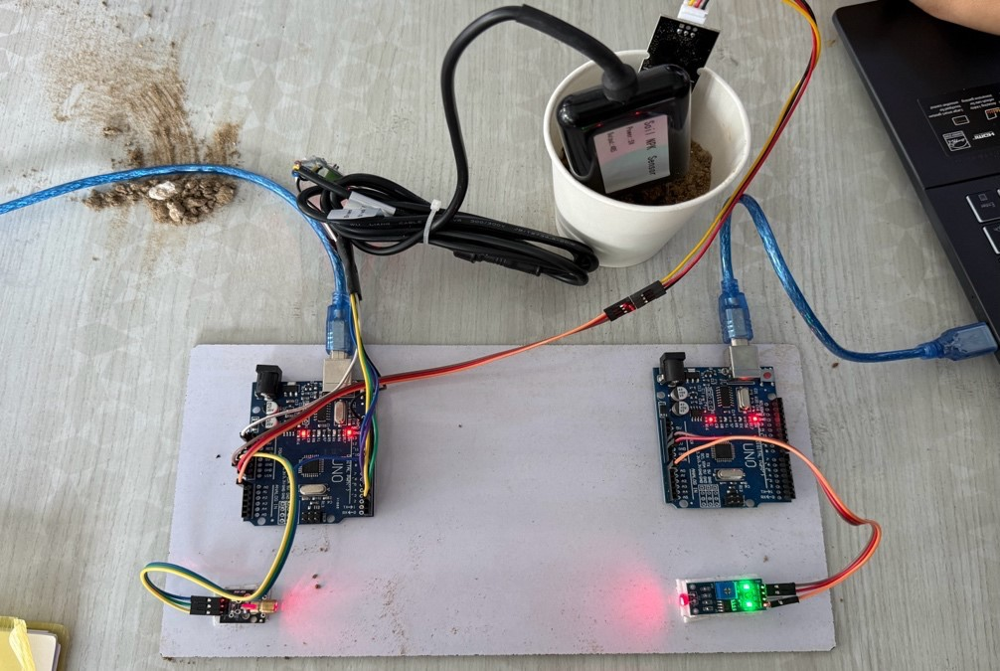
Fig. 1. Hardware setup of the proposed soil monitoring and optical communication system

Working Principle
The working of the system involves sequential stages of sensing, processing, transmission, and reception. Initially, the soil moisture sensor measures the water content in the soil by detecting variations in capacitance, while the NPK sensor provides nutrient values through RS485 communication. The transmitter Arduino reads the analog moisture values using its ADC and acquires digital NPK data via serial communication.
The acquired data is then processed and encoded into a digital format suitable for transmission. The laser diode transmits the encoded data as a series of light pulses, where the presence and absence of light represent binary logic levels. This method of transmission corresponds to on-off keying (OOK), a basic form of intensity modulation used in optical communication systems [7].

At the receiver end, the LDR module detects the incoming light signals and converts them into electrical signals. The receiver Arduino processes these signals, decodes the transmitted data, and reconstructs the original sensor values. The final output is displayed through the serial monitor or connected display system. This process demonstrates a complete optical communication link integrated with sensor-based data acquisition.
The operational flow of the proposed system is illustrated in Fig. 2, which represents the sequential execution of sensing, processing, transmission, and reception stages.
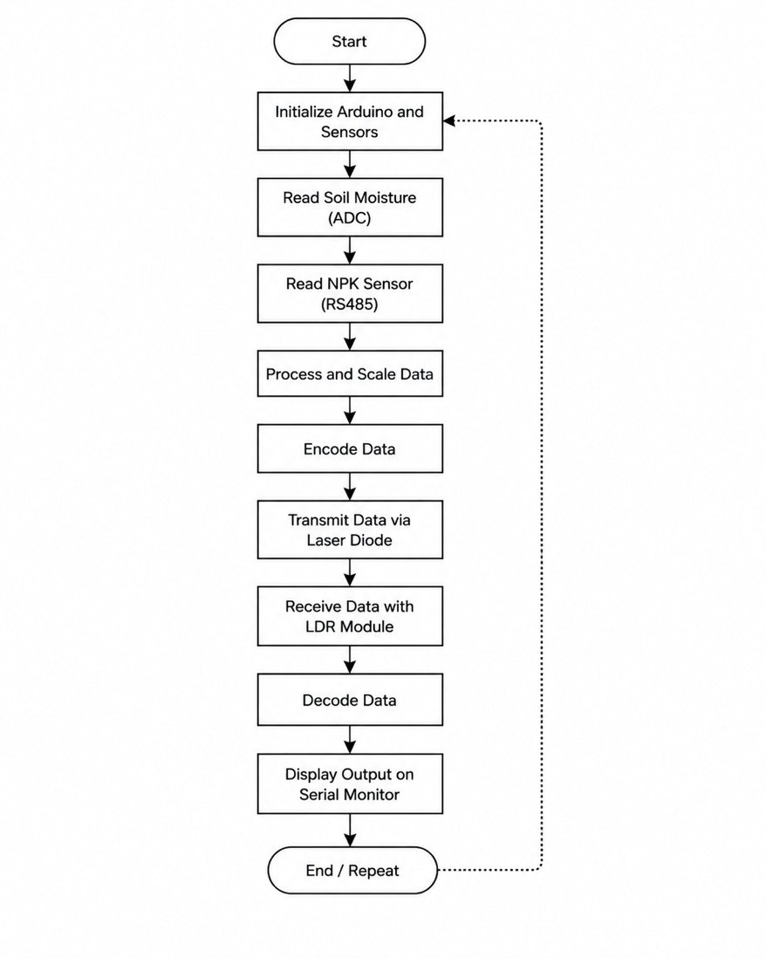
Fig. 2. Flowchart of the proposed soil monitoring and optical communication system

4.6 Implementation
The system was implemented as a prototype using readily available hardware components. The sensors were inserted into soil samples, and the transmitter and receiver units were positioned to maintain proper alignment between the laser and LDR module. The system was tested under varying soil moisture conditions to evaluate performance and reliability.

The implementation demonstrates a cost-effective and practical approach to soil monitoring using embedded systems and optical communication. Compared to IoT-based systems that rely on cloud connectivity and internet infrastructure [1][5], the proposed system operates independently, making it suitable for deployment in remote or resource-constrained environments. The use of optical communication further enhances security and reduces interference, aligning with the advantages reported in optical communication research [6][7].

Results

Experimental Setup
The proposed soil monitoring and optical communication system was experimentally validated in a controlled indoor laboratory environment. Soil samples with varying moisture conditions were prepared and placed in a container, and both the capacitive soil moisture sensor and the RS485-based NPK sensor were inserted into the soil to obtain real-time measurements. The system consisted of two Arduino Uno microcontrollers configured as transmitter and receiver units. The transmitter acquired sensor data and transmitted it using a 650 nm laser diode, while the receiver employed an LM393-based LDR module to detect optical signals and reconstruct the transmitted data.
The laser transmitter and receiver were aligned at a distance of approximately 25 cm to maintain line- of sight communication, which is a fundamental requirement in optical wireless systems [6]. The entire system was powered using a 5V USB supply, and the output was monitored through the Arduino serial interface. The experimental setup follows a simplified implementation of optical wireless communication systems, which have been widely studied for short-range secure data transmission [7]. Similar sensor based agricultural monitoring setups have been implemented in embedded systems for precision farming applications [1][3].

Observations
The system generated both raw and processed sensor readings. The raw readings correspond to the direct analog-to-digital converter (ADC) output of the moisture sensor, whereas the processed values were obtained by applying scaling techniques to enhance readability and interpretation. Such signal conditioning and scaling are commonly used in embedded sensing systems to improve data usability [5].

Table I. Output in Different Soil Conditions

Sample | Moisture (ADC) | Condition | Nitrogen (mg/kg) | Phosphorus (mg/kg) | Potassium (mg/kg)
S1 | 4200 | Very Dry | 600 | 390 | 0
S2 | 3800 | Dry | 600 | 390 | 0
S3 | 3150 | Moderate | 600 | 390 | 0
S4 | 3000 | Med. Moist | 600 | 390 | 0
S5 | 2700 | Moist | 600 | 390 | 0
S6 | 2500 | Wet | 600 | 390 | 0

The observed results indicate an inverse relationship between moisture readings and soil water content, where higher ADC values correspond to dry soil conditions and lower values indicate higher moisture levels. This behaviour is consistent with the working principle of capacitive soil moisture sensors, which measure changes in the dielectric constant of the soil medium [3]. The NPK sensor values remained relatively constant across samples, which can be attributed to uniform soil composition and the absence of calibration, a limitation commonly reported in low-cost soil sensing systems [3].

Performance Metrics
The performance of the system was evaluated in terms of accuracy, response time, sensitivity, and power consumption. The moisture sensor exhibited consistent readings across repeated measurements with an estimated variation of ±3–5%, while the NPK sensor showed variations within ±5–8%, which aligns with the performance characteristics of similar agricultural monitoring systems [3]. The total response time of the system, including sensing, transmission, and decoding, was approximately 2–3 seconds.

The optical communication link demonstrated stable data transmission within the tested range when proper alignment was maintained. The LDR module successfully detected variations in laser intensity; however, minor sensitivity to ambient light was observed. This behaviour is consistent with optical receiver characteristics discussed in photonics-based communication systems [8]. The system consumed approximately 120–130 mA, indicating suitability for low-power embedded applications.

Output Results
The output of the proposed system was observed using the serial monitor interface of the Arduino development environment. The system generated both raw sensor readings and processed (scaled) values, which were transmitted through the laser-based optical communication link and successfully reconstructed at the receiver end.

The processed sensor readings obtained after scaling are presented in Fig. 2. These values represent the final output of the system after applying signal processing techniques to improve readability and interpretability. It can be observed that the moisture values and corresponding NPK readings are clearly distinguishable, allowing better analysis of soil conditions. The scaling process enhances the resolution of the sensor output without affecting the underlying measurement accuracy, which is a common practice in embedded sensing systems [5].
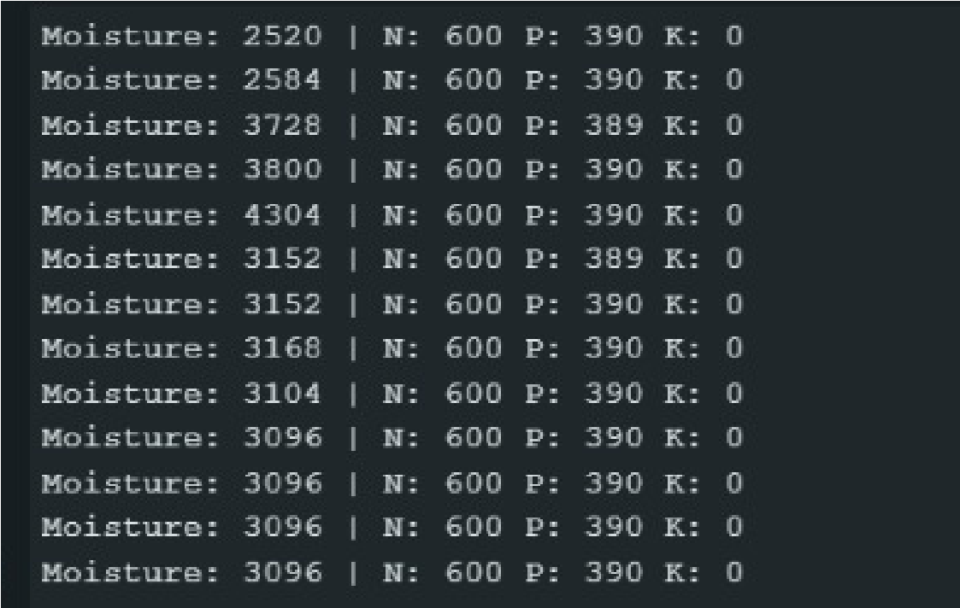
Fig. 3. Serial monitor output for scaled sensor readings

The raw sensor readings obtained directly from the sensors prior to scaling are shown in Fig. 3. These values correspond to the original ADC outputs and unprocessed NPK data acquired by the transmitter unit. The presence of occasional synchronization errors, indicated by “Sync lost…” messages, can also be observed. These errors occur due to minor misalignment or environmental disturbances affecting the optical communication link, which is consistent with the behavior of free-space optical systems [7][8].
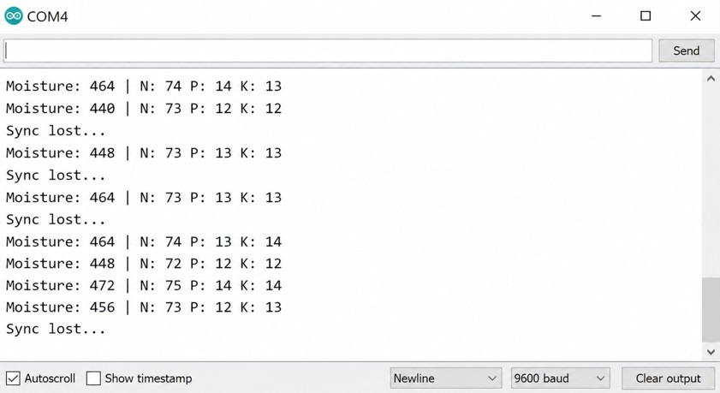

Fig. 4. Serial monitor output for raw sensor readings
A comparison between the raw and processed outputs highlights the importance of signal conditioning in embedded systems. While the raw values provide direct sensor measurements, the processed values offer improved clarity and usability for analysis and interpretation. The successful transmission and reconstruction of both types of data demonstrate the reliability of the proposed laser-based communication system under controlled conditions.

Discussion
The experimental results demonstrate that the proposed system effectively integrates soil sensing with optical wireless communication. Compared to traditional RF-based wireless sensor networks used in precision agriculture [3], the proposed system offers reduced susceptibility to electromagnetic interference, which is a well-known advantage of optical communication systems [6][7]. Additionally, unlike IoT-based agricultural systems that rely on cloud connectivity and internet infrastructure [1][5], the proposed system operates independently, making it suitable for deployment in remote or resource-limited environments.
The use of laser-based communication ensures a high level of security due to its directional nature, which minimizes the probability of signal interception. This characteristic is consistent with findings in optical communication research, where line-of-sight transmission provides enhanced data security [6]. However, the system also inherits inherent limitations of optical communication, including the requirement for precise alignment and sensitivity to environmental disturbances such as ambient light and physical obstructions [7][8].
The application of scaling to raw ADC values improved the interpretability of sensor outputs without altering the fundamental measurement accuracy. Such signal processing techniques are widely adopted in embedded systems to enhance data representation and usability [5]. Despite its advantages, the system is limited by its short communication range and lack of advanced modulation and error correction mechanisms, which restrict its applicability to low-data-rate, short-distance scenarios.
Overall, the proposed system demonstrates a cost-effective and innovative approach to soil monitoring by combining multi-parameter sensing with optical data transmission. The results are consistent with existing research in sensor-based agricultural systems and optical communication technologies, while also highlighting opportunities for future enhancements such as improved sensing accuracy, advanced communication techniques, and integration with IoT platforms [1][3][7].

References
- V. R. Balaji and M. S. Kumar, “Smart Farming Using IoT,” International Journal of Engineering Research & Technology, vol. 7, no. 3, 2018.
- N. Agrawal and S. Singhal, “Smart Drip Irrigation System Using Raspberry Pi and Arduino,” IEEE International Conference on Computing, Communication and Automation, 2015.
- S. R. Nandurkar, V. R. Thool, and R. C. Thool, “Design and Development of Precision Agriculture System Using Wireless Sensor Network,” IEEE International Conference on Automation, Control, Energy and Systems, 2014.
- A. R. Al-Ali, I. A. Zualkernan, and F. Aloul, “A Mobile GPRS-Sensors Array for Air Pollution Monitoring,” IEEE Sensors Journal, 2010.
- R. K. Kodali and S. Soratkal, “MQTT Based Home Automation System Using ESP8266,” IEEE Region 10 Conference, 2016.
- J. Hecht, Understanding Fiber Optics, 5th ed., Pearson, 2005.
- T. Komine and M. Nakagawa, “Fundamental Analysis for Visible-Light Communication System Using LED Lights,” IEEE Transactions on Consumer Electronics, 2004.
- D. A. Teich and B. E. A. Saleh, Fundamentals of Photonics, Wiley, 2007.

